**11/05/2023**

Micro system state basically weatlh distr. Over agents

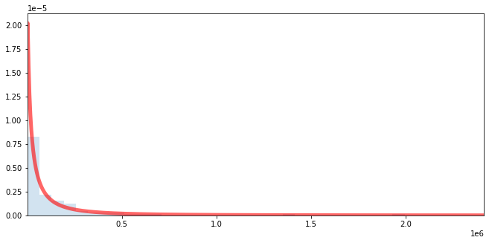

Kernel density estimates doesn’t work on this kind of fat tailed distr.

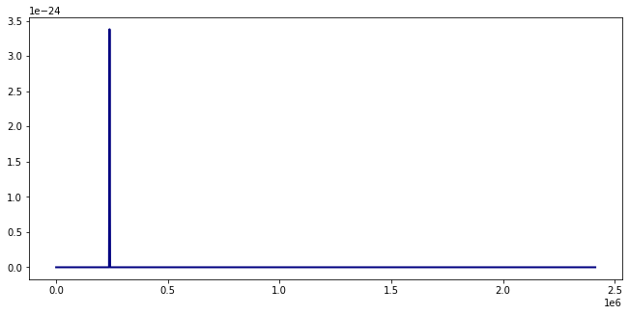

Hence log transformed wealth is taken

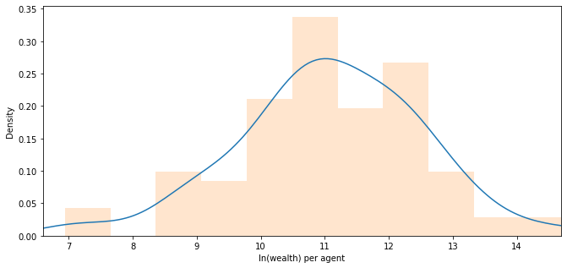

This is the ensemble of microstates. Where the x-axis is ln(wealth) of agents

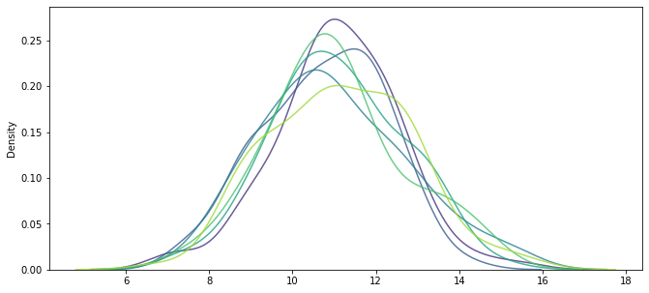

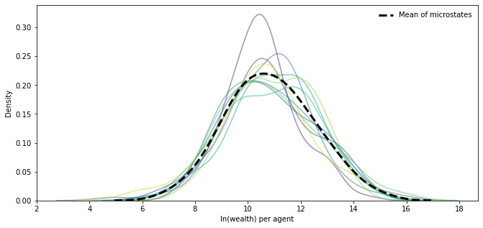

Before 11/05/2023

Attempts at plotting macro-state of EnkF

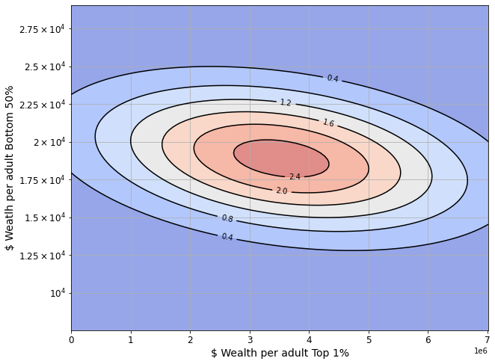

Plotting these variables logged is weird also.

